Name: ___________________________________ Date: ______________________ Period: _______

**Answer Key**

Predicting Genotypes

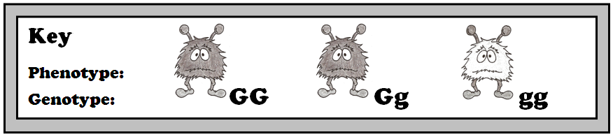

**Predict the genotypes of each set of parents based on the phenotypes of the parents and offspring. Assume that all possible phenotypes for the offspring are shown.**

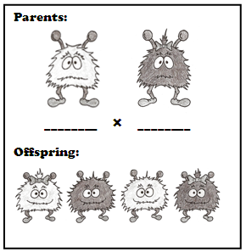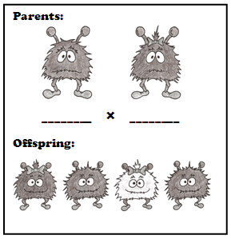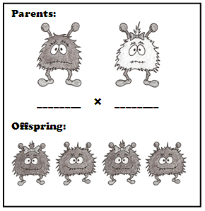

**Gg Gg**

**GG gg**

**gg Gg**

**For 2 gray aliens to have a white offspring, they must both be heterozygotes (Gg). So 1-4 must all have genotype Gg!**

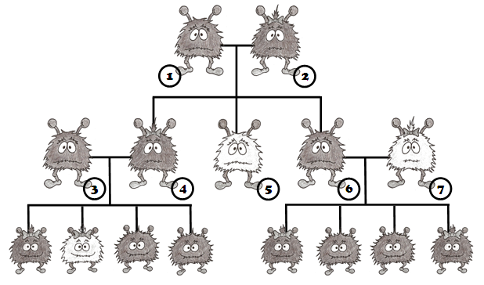

**Predict the most likely genotype of each numbered creature based on its phenotypes and the phenotypes of its offspring and parents.**

**1: ________ 5: ________**

**2: ________ 6: ________**

**3: ________ 7: ________**

**4: ________**

**gg**

**Gg**

**gg**

**Gg**

**Gg**

**Gg**

**Gg**

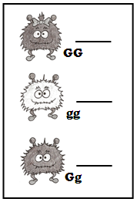

**2**

**Each child to the right belongs to a different set of parents below (1-3). Determine which child belongs to each set of parents.**

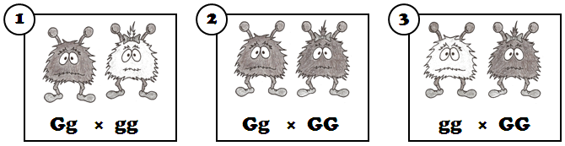

**1**

**ALL of the offspring will have genotype Gg, so that offspring must be theirs.**

**This is the only couple that can have white (gg) offspring, so that must be their offspring.**

**This couple could produce GG or Gg offspring, but the Gg offspring must belong to couple 3, so by default the GG offspring must be theirs.**

**3**

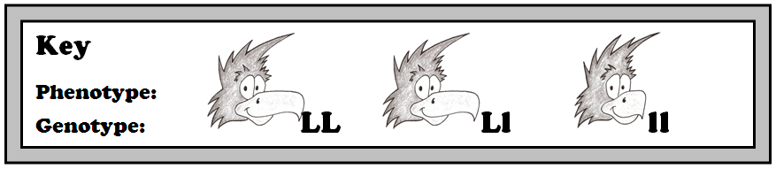

**Predict the genotypes of each set of parents based on the phenotypes of the parents and offspring. Assume that all possible phenotypes for the offspring are shown.**

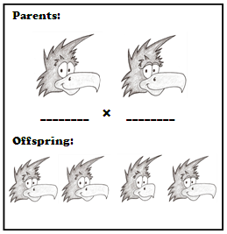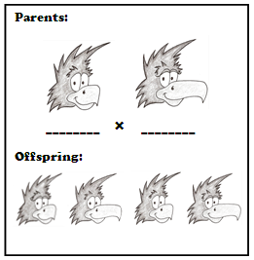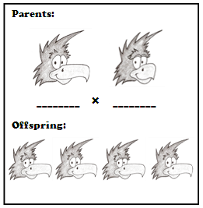

**LL ll**

**ll Ll**

**Ll Ll**

**For 2 long-beaked birds to have a short-beaked offspring, they must both be heterozygotes (Ll). So 1-4 must all have genotype Ll!**

**Predict the most likely genotype of each numbered creature based on its phenotypes and the phenotypes of its offspring and parents.**

**1: ________ 5: ________**

**2: ________ 6: ________**

**3: ________ 7: ________**

**4: ________**

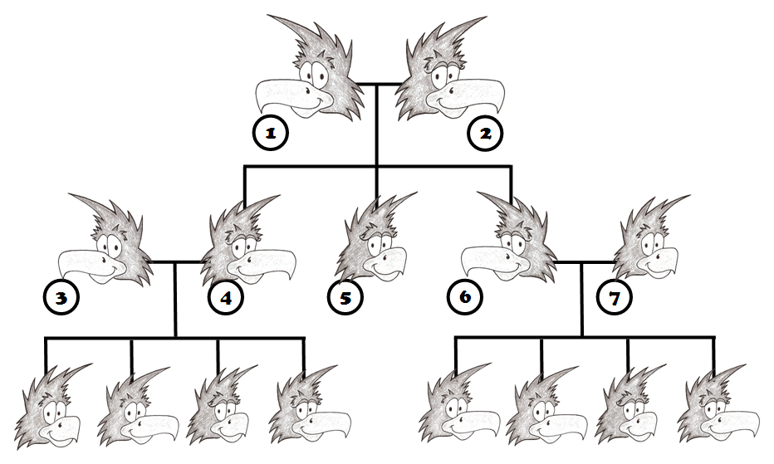

**ll**

**Ll**

**Ll**

**Ll**

**Ll**

**ll**

**Ll**

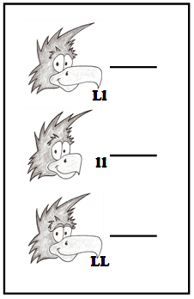

**2**

**3**

**1**

**Each child to the right belongs to a different set of parents below (1-3). Determine which child belongs to each set of parents.**

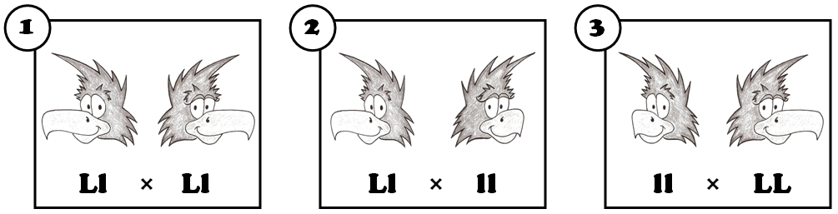

© Haney Science

**This is the only couple that can have homozygous dominant (LL) offspring, so that must be theirs.**

**ALL of the offspring will have genotype Ll, so that offspring must be theirs.**

**This couple could produce Ll or ll offspring, but the Ll offspring must belong to couple 3, so by default the ll offspring must be theirs.**